**Run Anywhere Development**

1. **User Stories:**
2. **Authorize**

**- user login**

**- user logout**

**- user signup**

**- user change password**

**- activation link embed user email (email + activation code + 48 hour limit)(?)**

**adv: so we know if the user has activated or not.**

**if activate, instruct to login**

**if email not exist, means: not signup, or pass activate time window**

**Mock UI:**

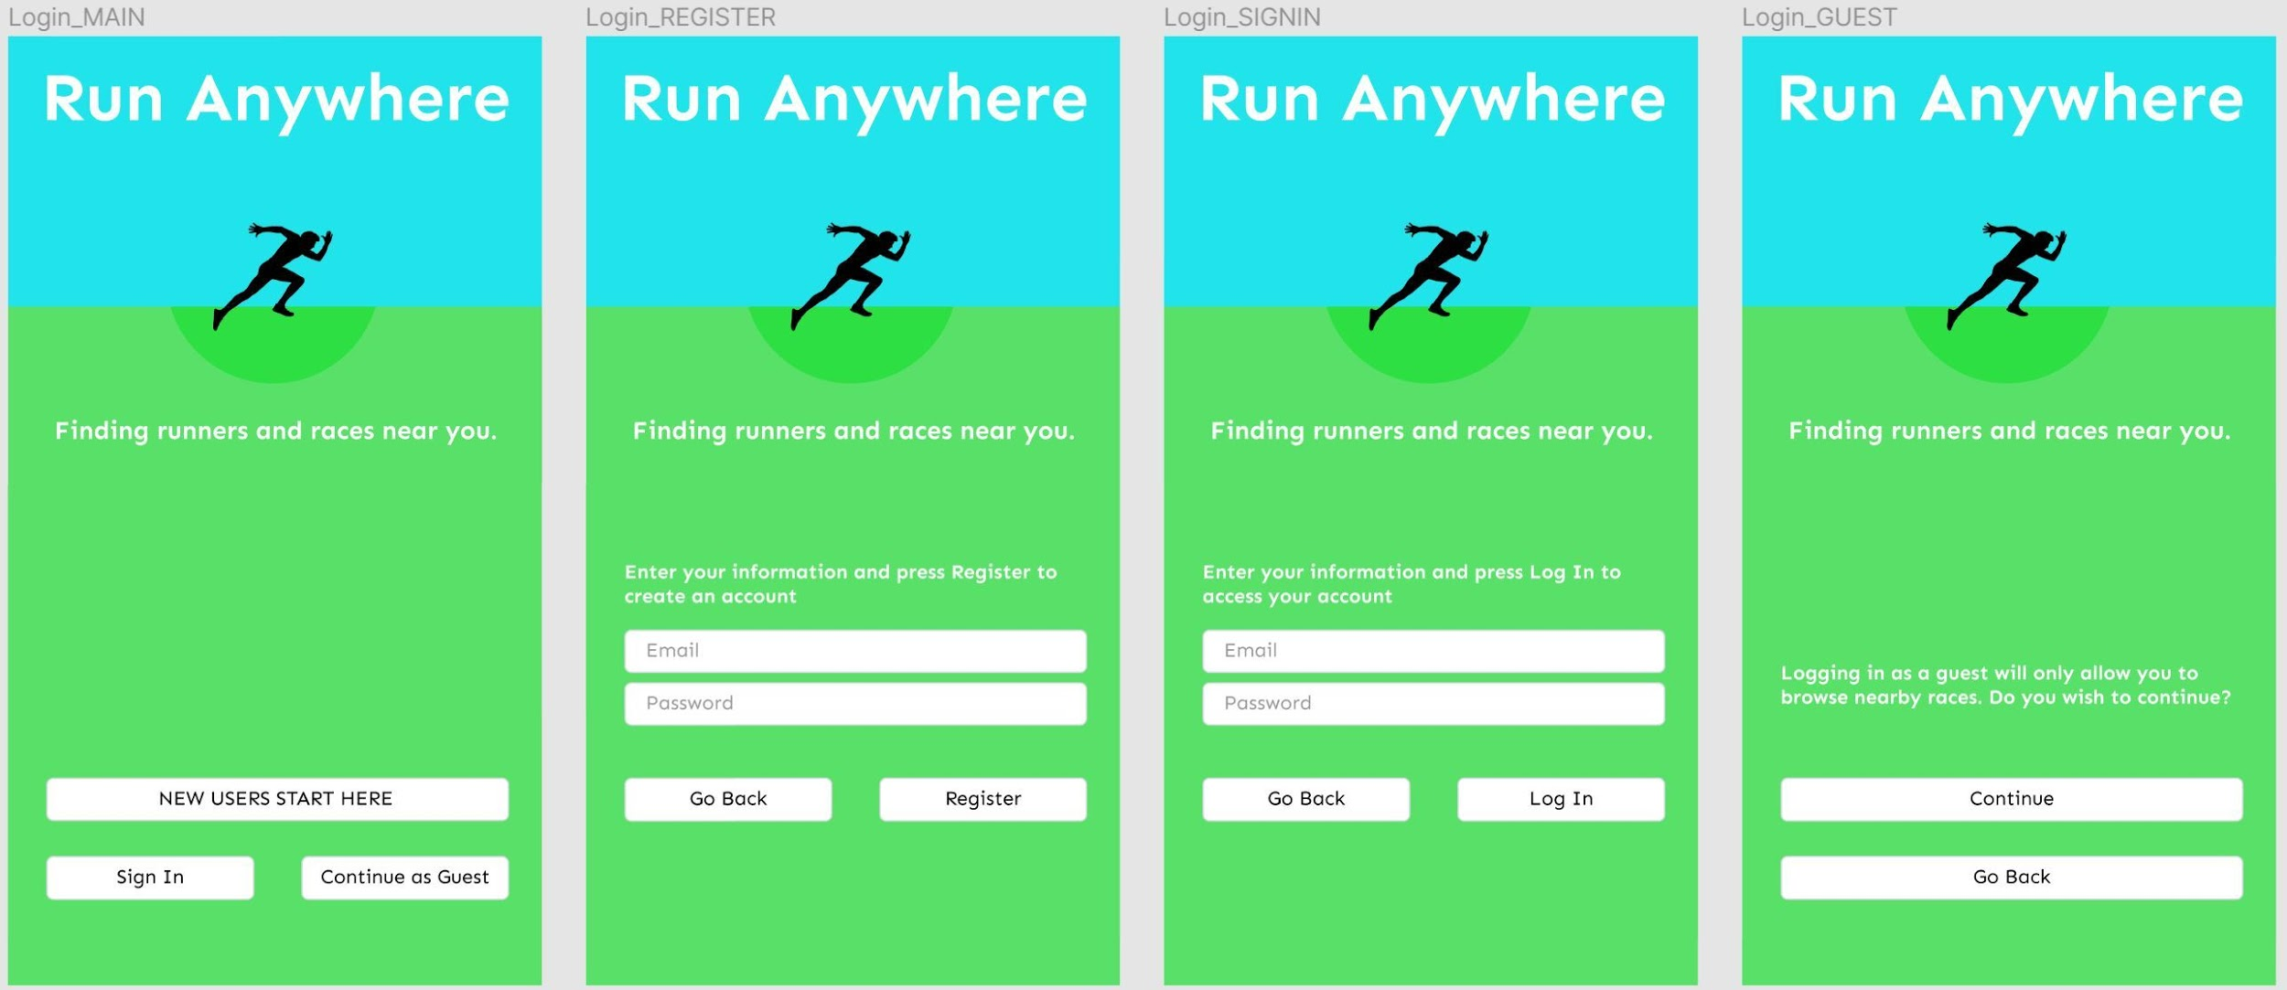

1. **GUEST**

**- as guest, can find races/events**

**- as guest, can search results**

**- as guest, check special race result and checkpoint timing**

**- as guest, live track runner at race time( tbd?)**

**Mock UI:**

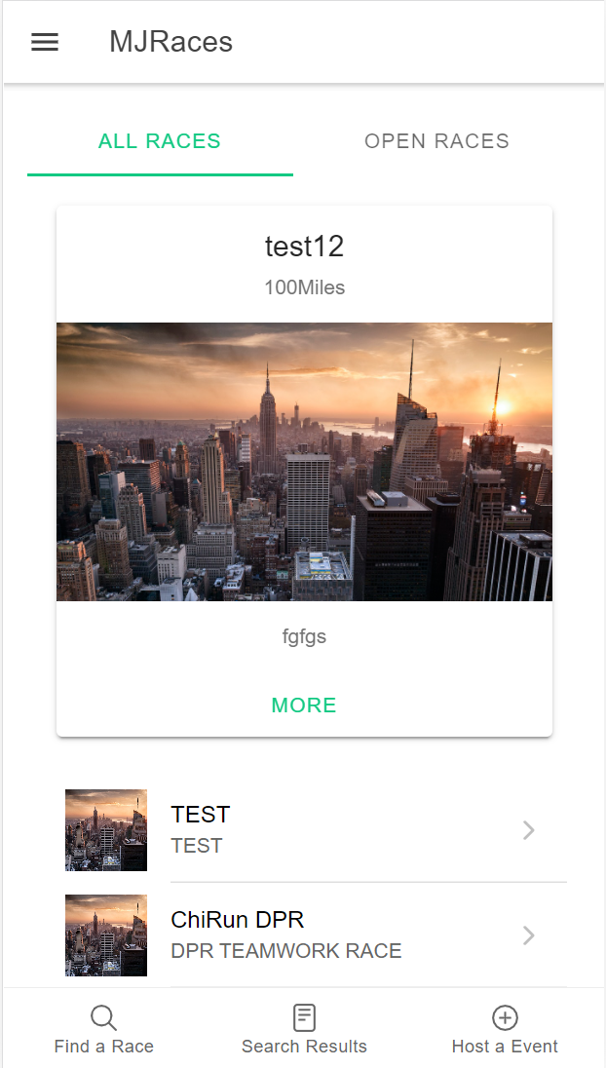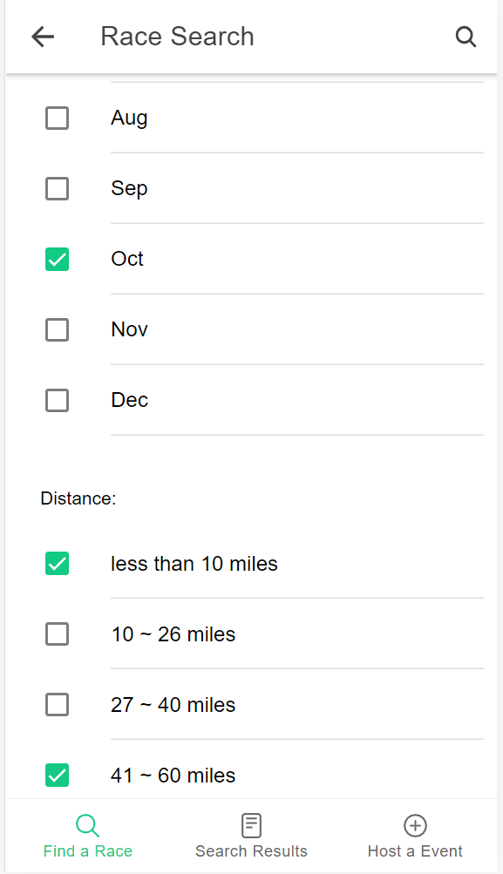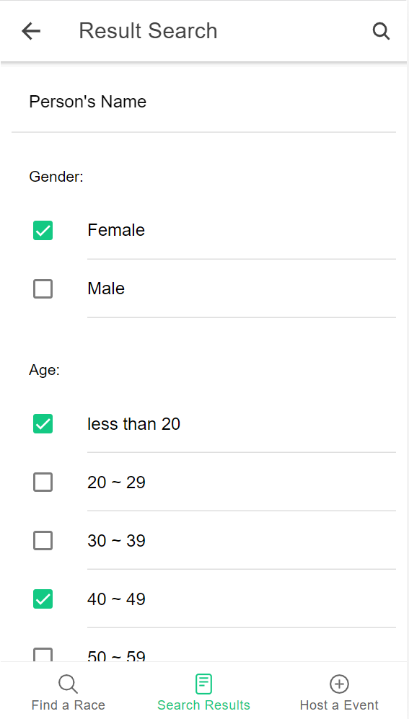

1. **RUNNER**

**- as runner, can create a profile**

**- as runner, can edit profile**

**- as runner, can register a race (showing the waiver form)**

**- as runner, can make payment(?)** CC payment:Square ( USA payment system, free for developers)?

**- as runner, can manage my races (eg. edit (address ) and cancel registration )**

**- as runner, can check my results**

**- as runner, can check my watch races**

**Mock UI:**

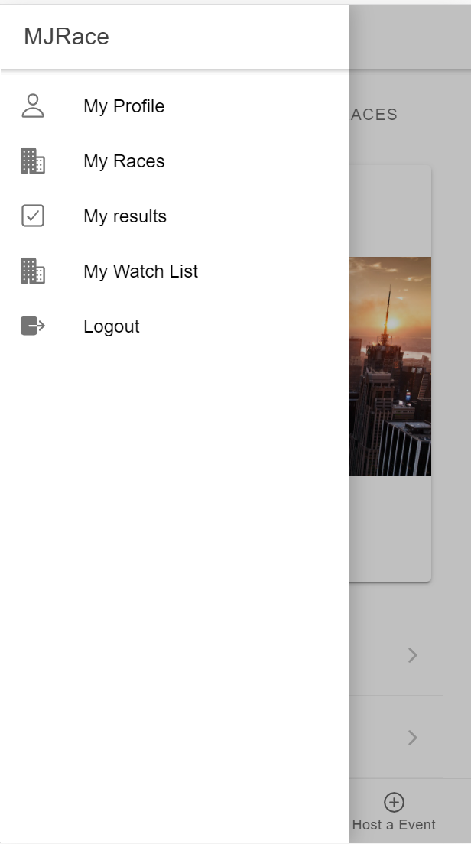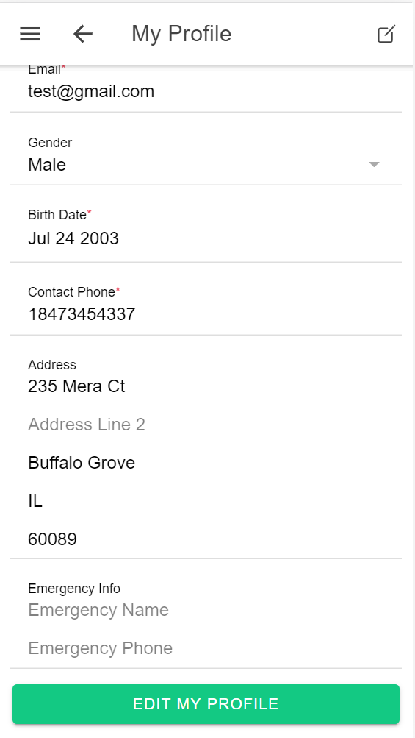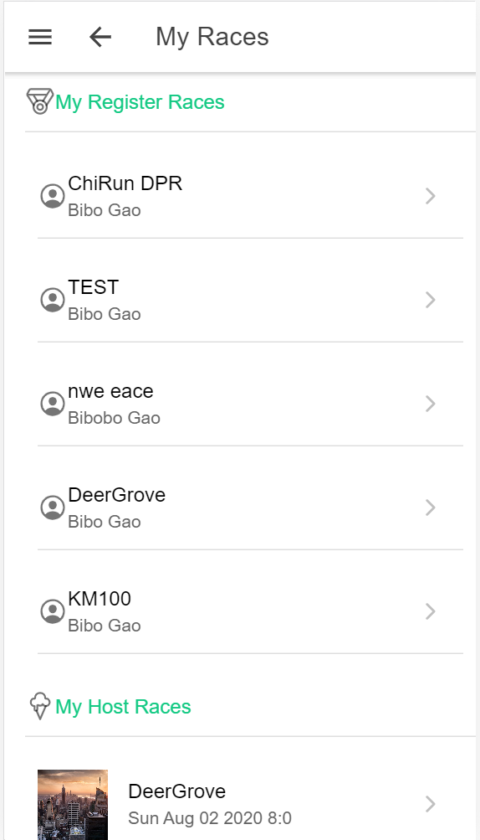

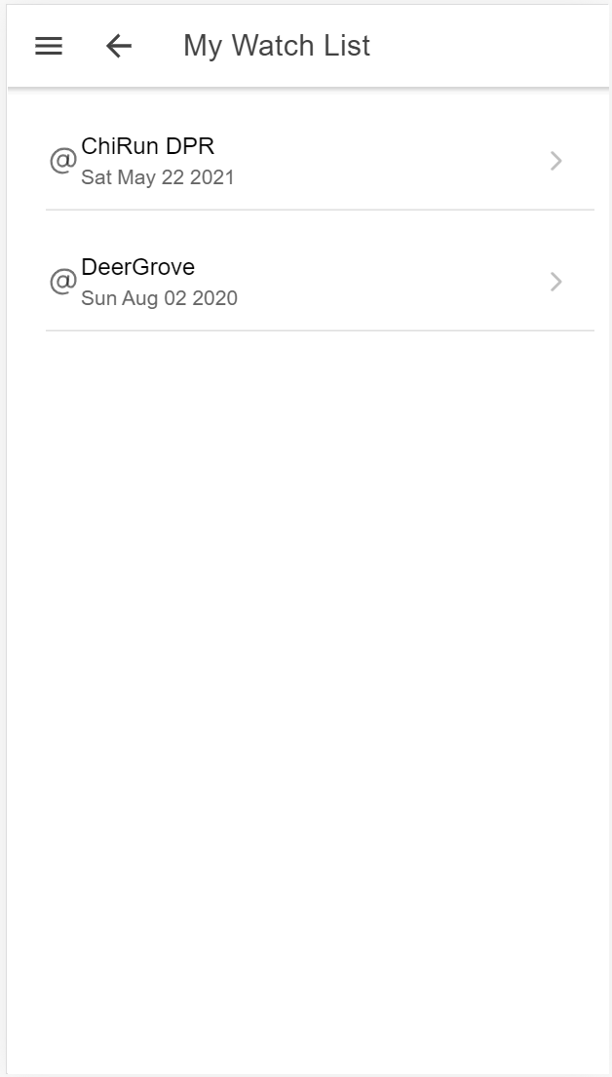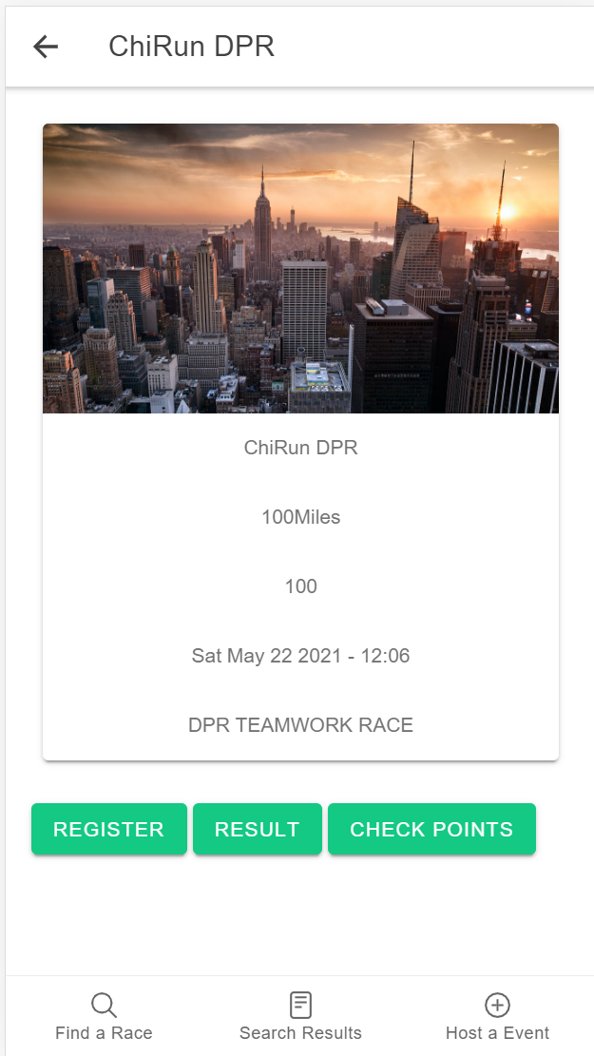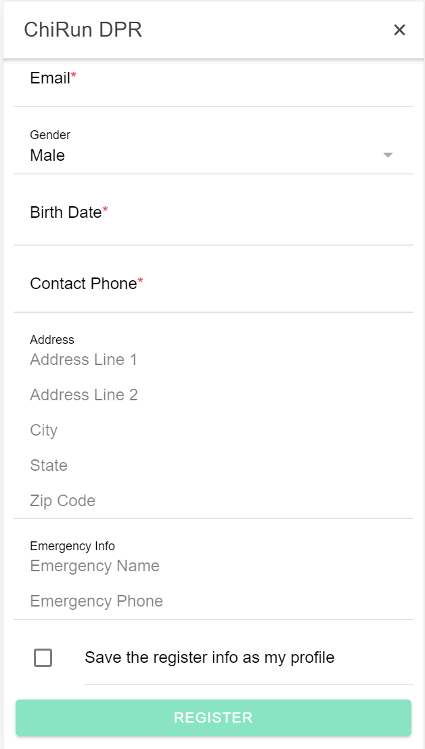

1. **Volunteer(TBD?)**

**- as volunteer, can create a profile**

**- as volunteer, can edit profile**

**- as volunteer, can see available races**

**- as volunteer, can see available jobs for a race**

**- as volunteer, can grab available jobs (self-assignment)**

1. **Race director**

**- as RD, can create a race**

**- as RD, can edit and delete his/her created race**

**- as RD, can upload race results**

**- as RD, can edit race results**

**- as RD, can manual assign bib#**

**- as RD, can automatic assign bib#**

**- as RD, can set checkpoint info**

**- as RD, can set checkpoint timing info for runners**

**- as RD, can view all runners information whose registered**

**- as RD, can view all volunteers**

**- as RD, can group send customized email to all runners (name will change for each email)**

**- as RD, can group send customized email to all volunteers(name will change for each email)**

**- as RD, can create volunteer jobs (TBD?)**

**- as RD, can assign volunteer jobs (TBD?)**

**- as RD, can set priceMatrix(TBD?)**

**Mock UI:**

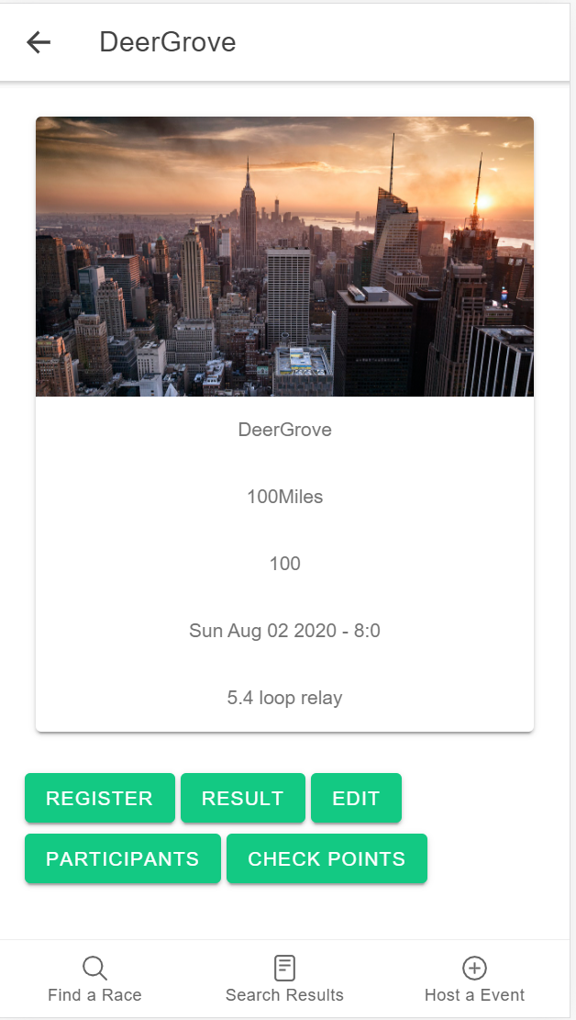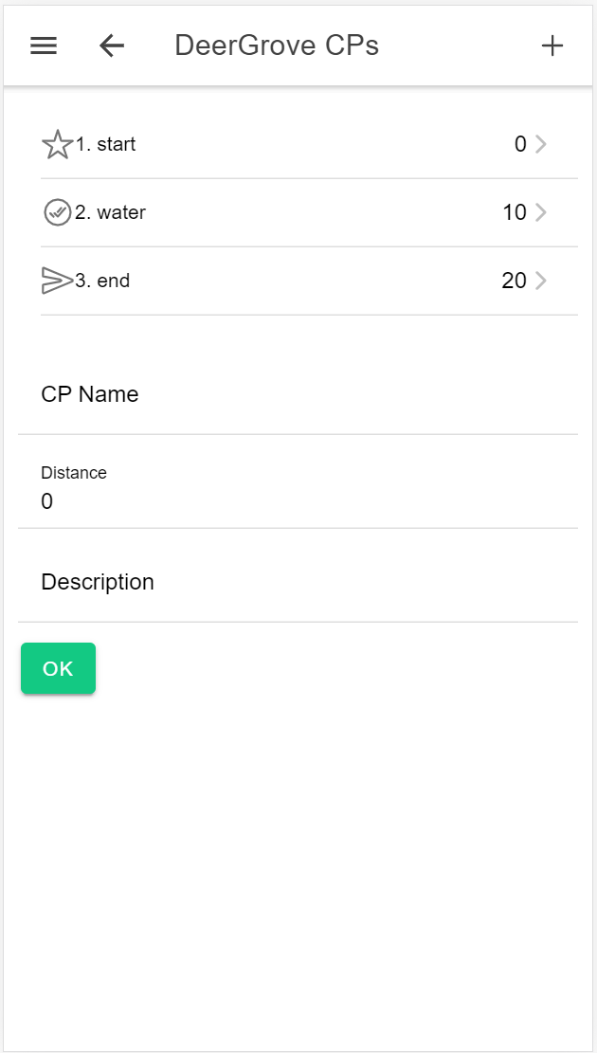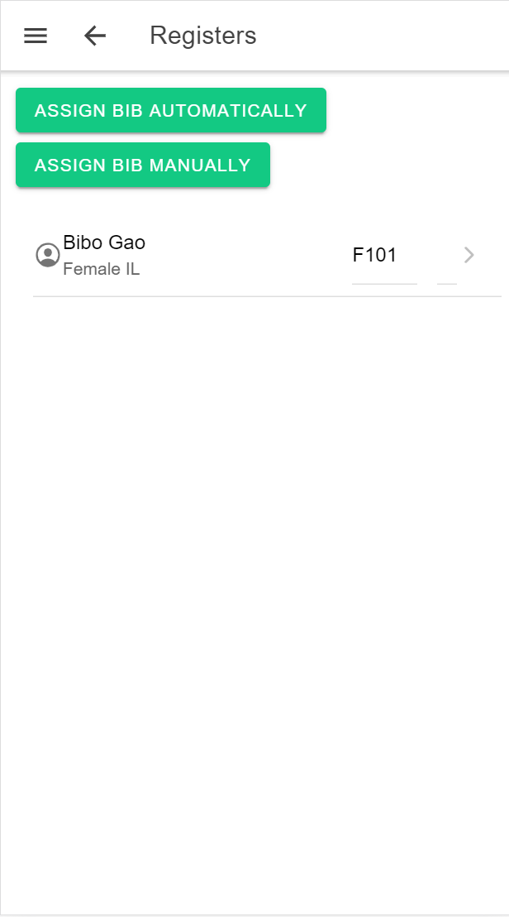

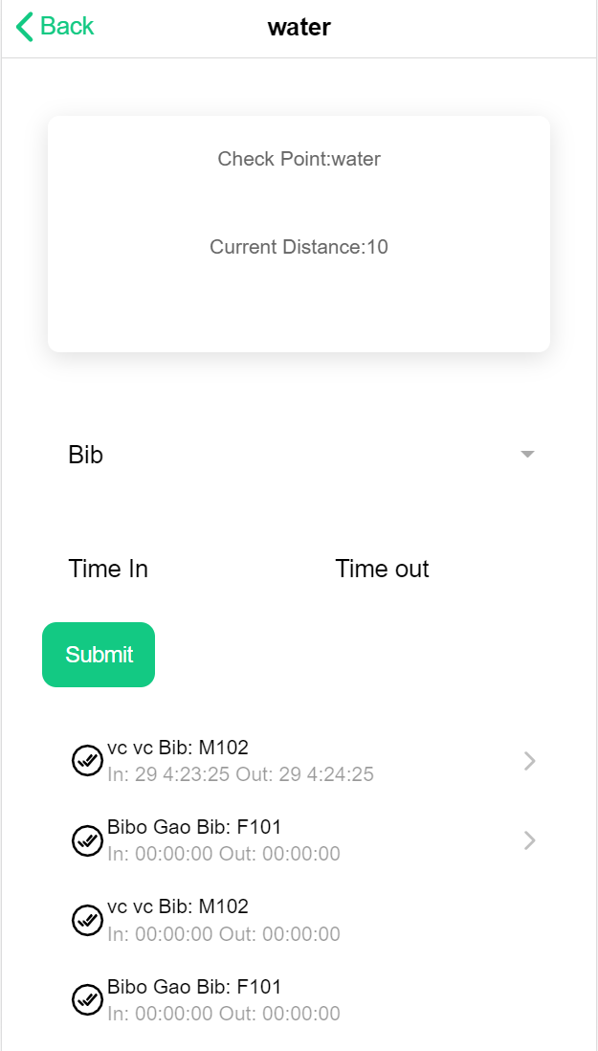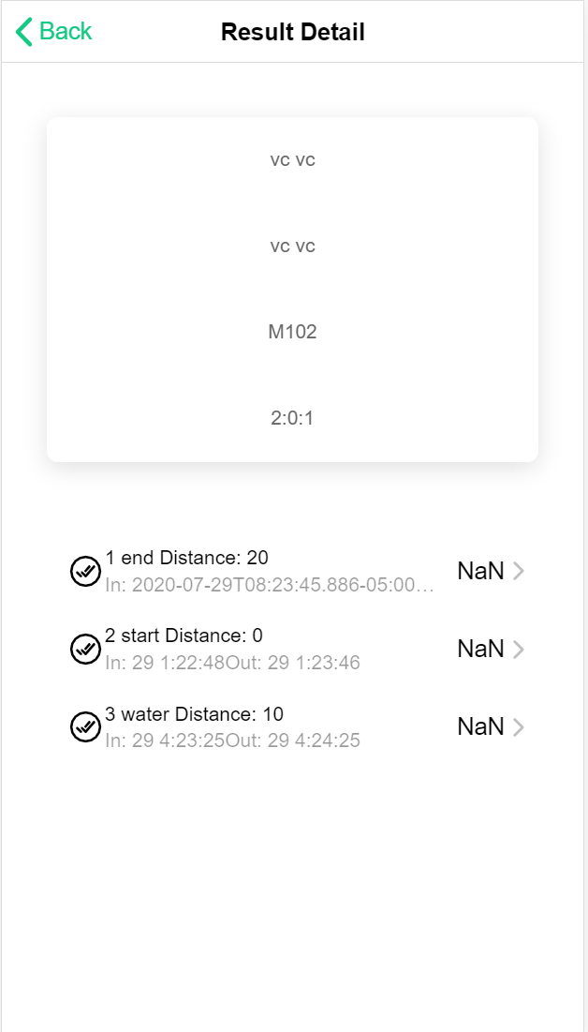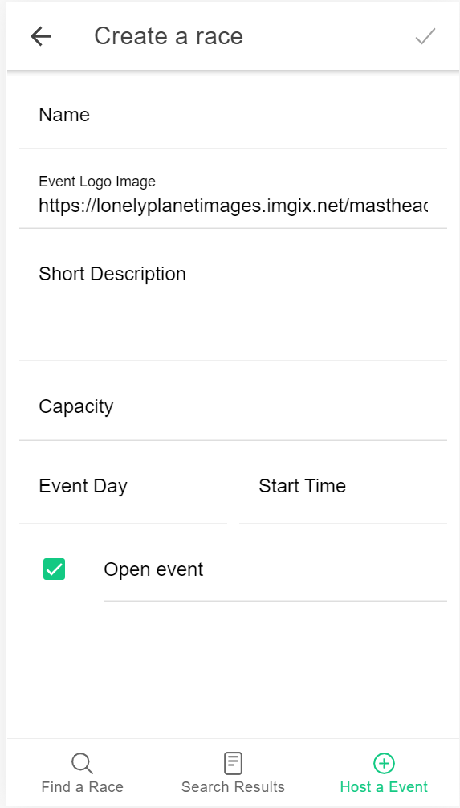

1. **Race Analysis and Report(TBD?)**

**- post-race data analysis**

**- age group ranking**

**- overall ranking**

**- finish rate**

**- avg time of finish etc**

**- send email/text when he/she crosses the finish line.**

**- report by email to runner if**

**- runner cross the finish line checkpoint**

**- the raceId is set active (under monitoring)**

1. **Design:**

* **FRONTEND: Cordova + IONIC Framework (TBD?)**

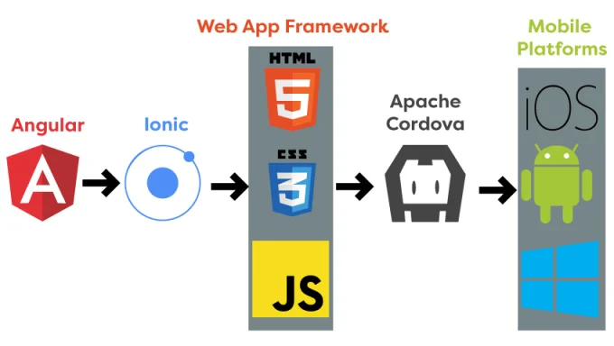

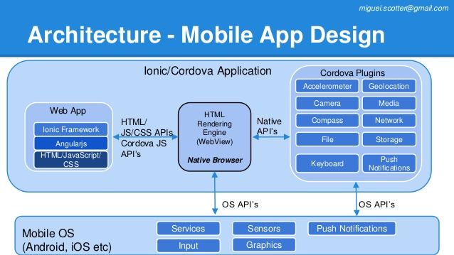

* **BACKEND: Firebase (TBD?)**

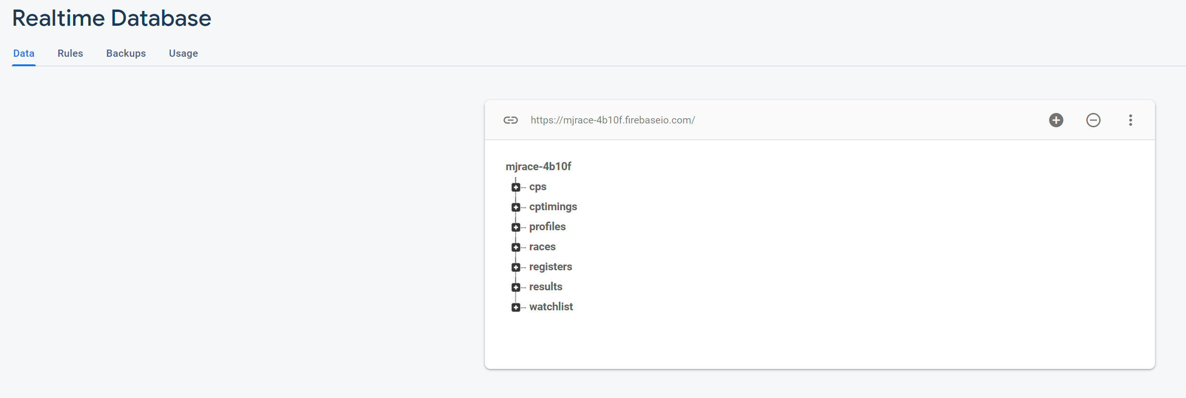

1. **Meeting To Do List:**

* **Decide the user stories and design**
* **Assign work**